|  |
| --- |
| GamingFUN |
| GAMEPROGRAMMING-1 |
| **Assignment-2** |
| Version #01  All work Copyright © 2016 by GamingFun.  All rights reserved. |
| **Padma Chakraborty** |
|  |

C:\Users\chakraborty\Downloads\logo_1956770_web.jpg

|  |
| --- |
| February 29,2016 |

**Table of Contents**

**Page**

Detailed Game Description \_\_\_\_\_\_\_\_\_\_\_\_\_\_\_\_\_\_\_\_\_\_\_\_\_\_\_\_\_\_\_\_\_\_\_\_\_\_\_ 3

Controls \_\_\_\_\_\_\_\_\_\_\_\_\_\_\_\_\_\_\_\_\_\_\_\_\_\_\_\_\_\_\_\_\_\_\_\_\_\_\_\_\_\_\_\_\_\_\_\_\_\_\_\_\_\_\_ 3

Interface Sketch \_\_\_\_\_\_\_\_\_\_\_\_\_\_\_\_\_\_\_\_\_\_\_\_\_\_\_\_\_\_\_\_\_\_\_\_\_\_\_\_\_\_\_\_\_\_\_\_\_ 3

Screen Descriptions \_\_\_\_\_\_\_\_\_\_\_\_\_\_\_\_\_\_\_\_\_\_\_\_\_\_\_\_\_\_\_\_\_\_\_\_\_\_\_\_\_\_\_\_\_\_ 4

Characters / Vehicles \_\_\_\_\_\_\_\_\_\_\_\_\_\_\_\_\_\_\_\_\_\_\_\_\_\_\_\_\_\_\_\_\_\_\_\_\_\_\_\_\_\_\_\_\_ 5

Enemies \_\_\_\_\_\_\_\_\_\_\_\_\_\_\_\_\_\_\_\_\_\_\_\_\_\_\_\_\_\_\_\_\_\_\_\_\_\_\_\_\_\_\_\_\_\_\_\_\_\_\_\_\_\_\_\_ 5

Scoring \_\_\_\_\_\_\_\_\_\_\_\_\_\_\_\_\_\_\_\_\_\_\_\_\_\_\_\_\_\_\_\_\_\_\_\_\_\_\_\_\_\_\_\_\_\_\_\_\_\_\_\_\_\_\_\_\_ 6

Sound Index \_\_\_\_\_\_\_\_\_\_\_\_\_\_\_\_\_\_\_\_\_\_\_\_\_\_\_\_\_\_\_\_\_\_\_\_\_\_\_\_\_\_\_\_\_\_\_\_\_\_\_\_\_ 6

Art / Multimedia Index \_\_\_\_\_\_\_\_\_\_\_\_\_\_\_\_\_\_\_\_\_\_\_\_\_\_\_\_\_\_\_\_\_\_\_\_\_\_\_\_\_\_\_ 6

**Version History**

Game Overview

1. **Detailed Game Description**

*The game is about a monkey trying to steal bananas from different locations in the garden such as on the ground, banana tree and a basket that contains bananas. Men holding guns are safeguarding the bananas. If the monkey is successful in stealing a banana, it can score points but if it collides with the enemy who is a man holding the gun, then it loses one of its life.*

1. **Controls**

*The monkey can be navigated in all directions by using the arrow keys or WASD keys on the keyboard. The monkey jumps when the up-arrow button is clicked and moves left or right in the garden based on the left and right arrow keys.*

1. **Interface Sketch**

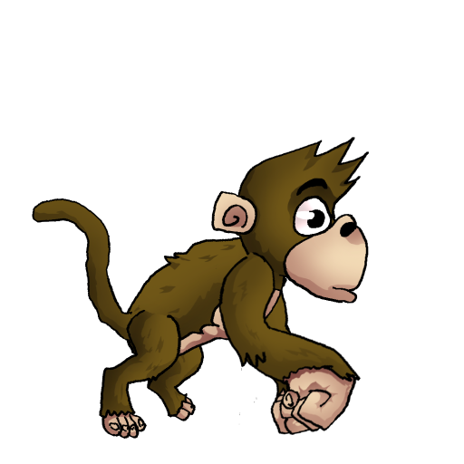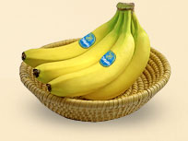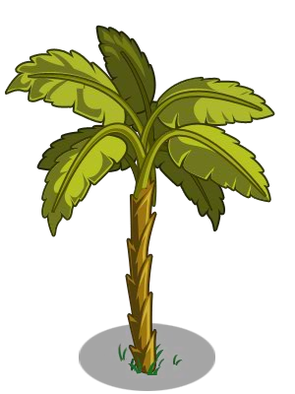https://encrypted-tbn2.gstatic.com/images?q=tbn:ANd9GcSy512Pc8W6c7hTVqm7g2TK7SvGSzLJUZ6N1XIcBYNUYbydrRXj

Score:10

Lives:0

HIGH SCORE:10

GAME OVER

H

RESTART

H

1. **Screen Descriptions**

***Game Start***

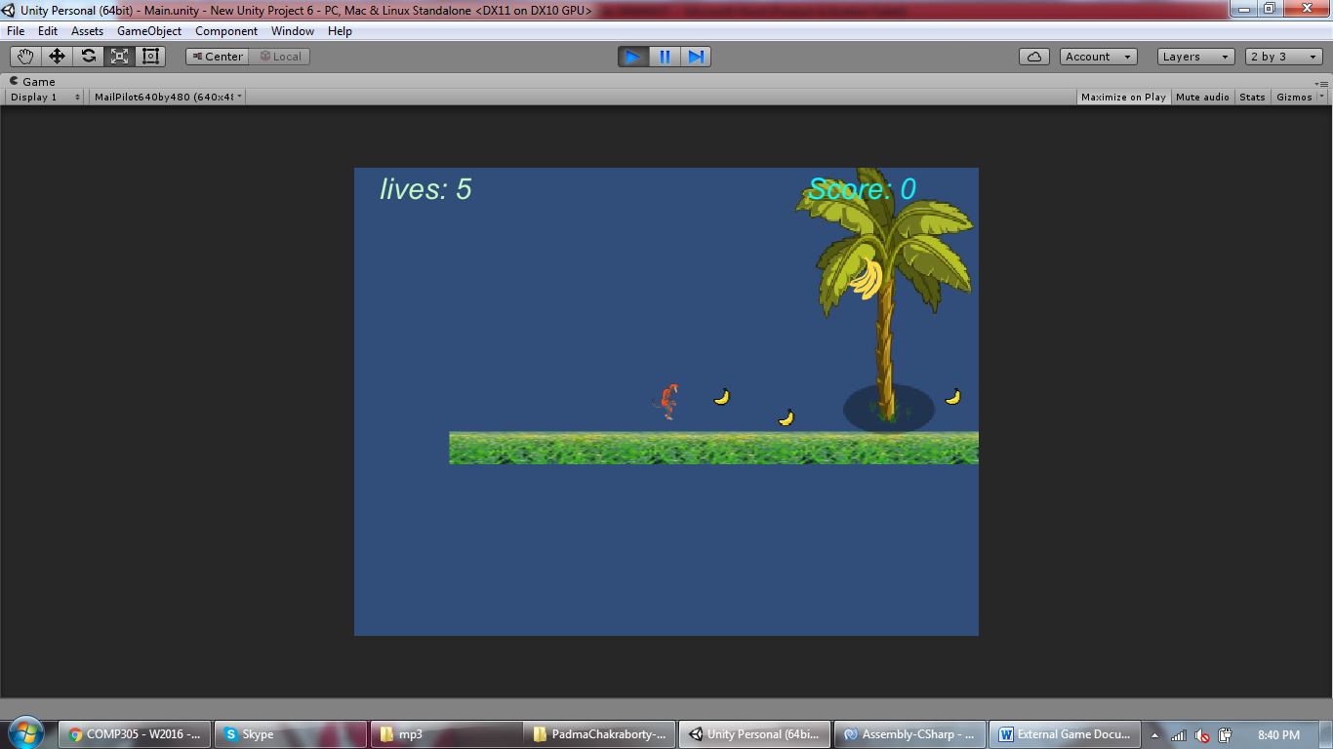

***Game On***

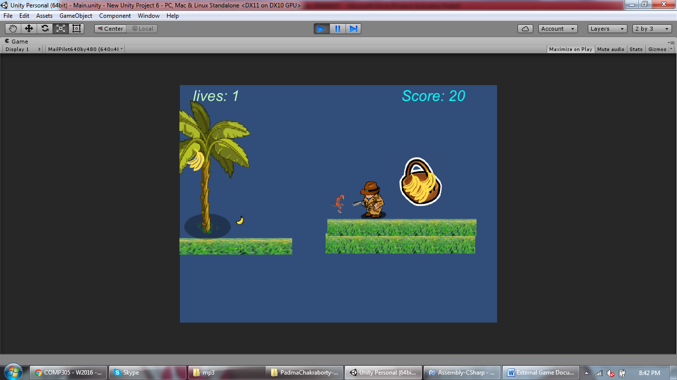

***Game Over***

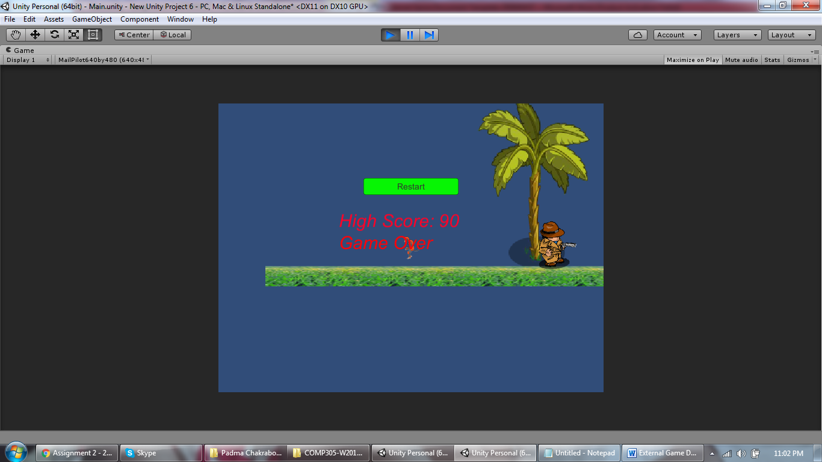

1. **Characters / Vehicles**

*The character is a monkey that can jump and move in both directions. The other characters are bananas that placed on different locations. The game also contains banana trees with bananas and a basket that contains bananas.*

1. **Enemies**

*The enemy is a man holding a gun who is trying to avoid the monkey from picking up bananas from the basket*

1. **Scoring**

*10 points is added when the monkey picks up a banana. When the monkey picks up a bunch of bananas, 30 points are added to the score. When the monkey collides with the gun man, the monkey loses one of its lives. The monkey has totally five lives in the game to survive. The lives are also reduced by one when the monkey reaches the dead end of the game.*

1. **Sound Index**

*jumpAudio –This audio is used when the monkey takes a jump.*

*bananAudio=This audio is used when the monkey steals a banana or bunch of bananas.*

*enemyaudio – This audio is used when the monkey comes in contact with the man.*

1. **Art / Multimedia Index**

***Vehicle/Avatar***

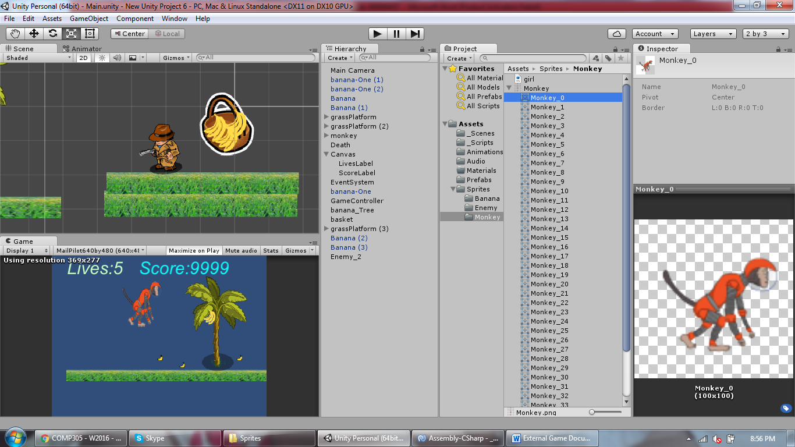

***Enemy***

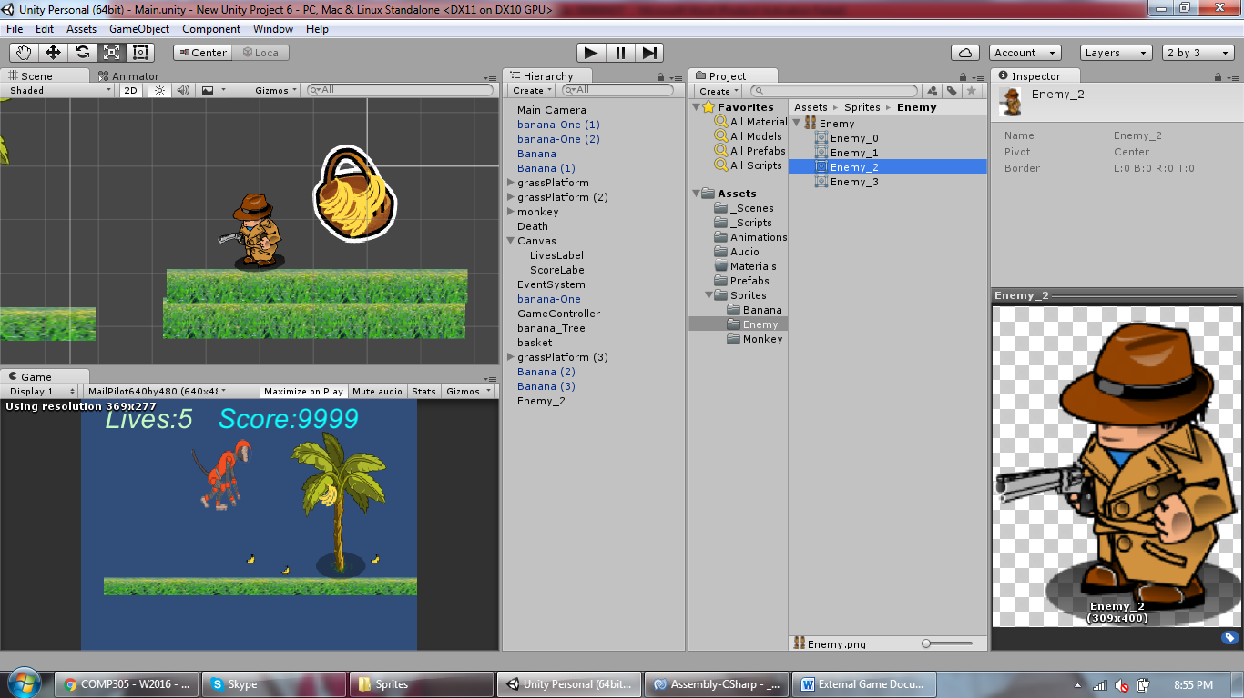

***Points gainer***

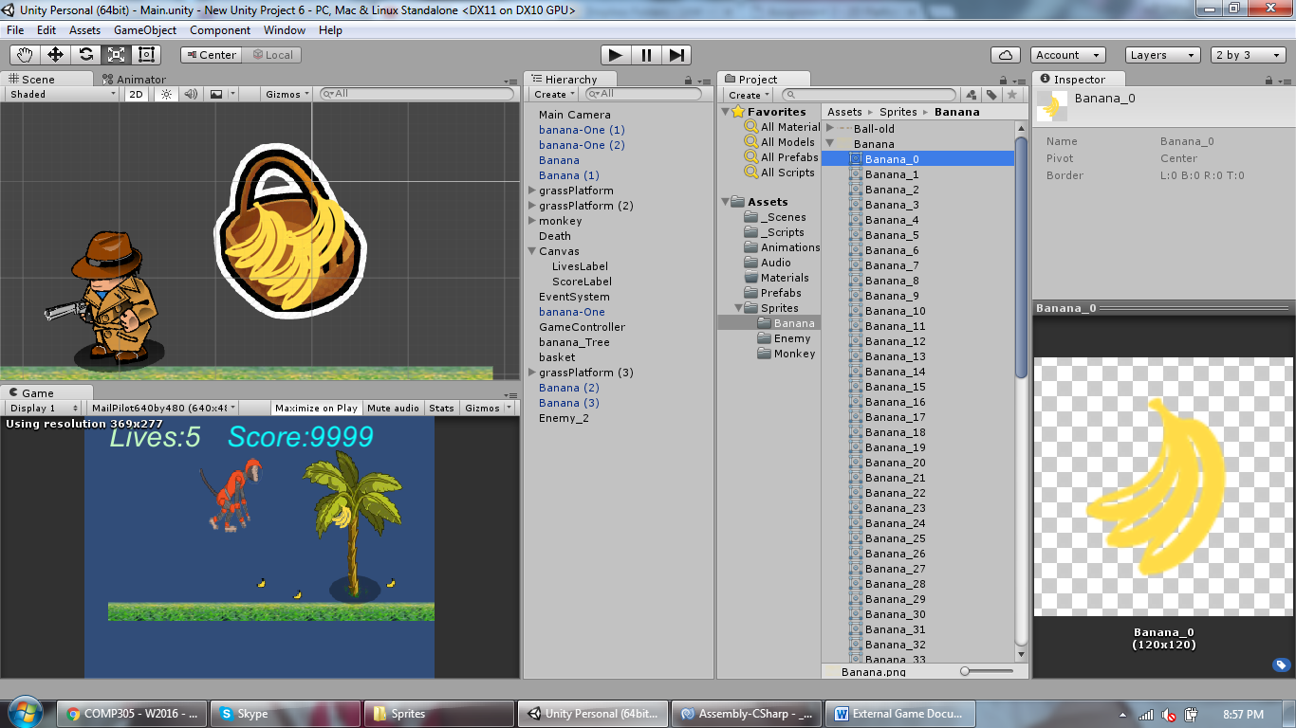 *C:\PADMA\Centennial documents\Jan-Apr,2016\GameProgramming\New Unity Project 6\Assets\Sprites\Banana\banana-One.gif*

***Additional Resources***

*